Cahier des charges du projet

“photoStockage”

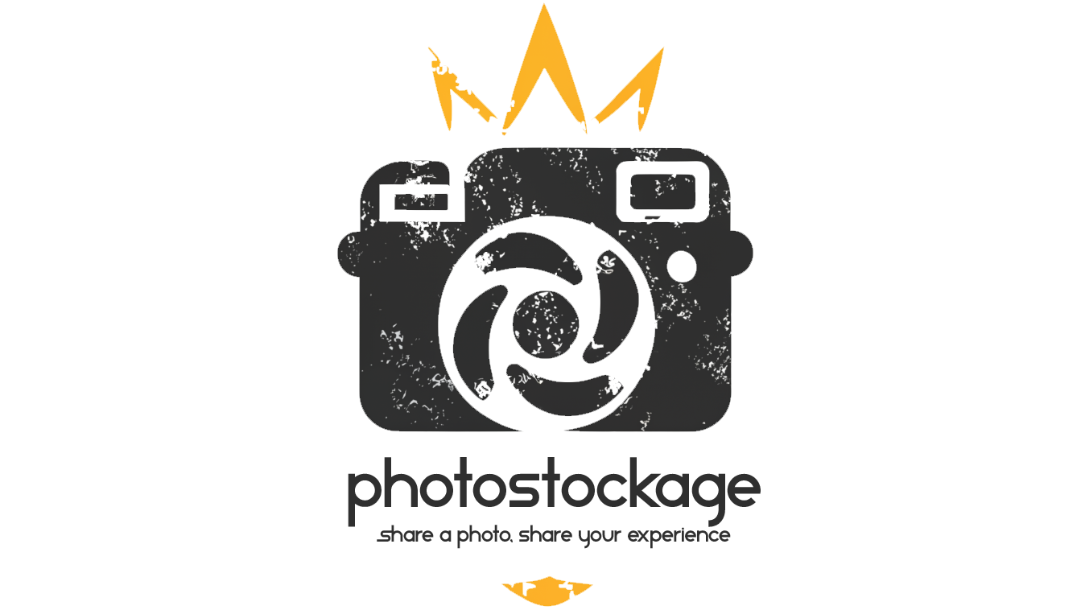

Index

I. Introduction

II. Objectives

i. Functional objectives

ii. Non-functional objectives

III. Stakeholders

i. Project Team

ii. End Users

IV. Requirements

i. Functional requirements

ii. Non-functional requirements

V. Technical Specifications

i. Platforms

ii. Technology Stack

iii. Integration

VI. Design and User Experience

i. Wireframes

ii. Maquettage

iii. User Journey

iv. Visual design

VII. Data Management

i. Data Models

ii. Data Storage

VIII. Testing and Quality Assurance

i. Testing strategy

ii. Quality Criteria

IX. Project Timeline and Milestones

i. Phases

ii. Milestones

X. Resources

XI. Legal and Compliance

i. Intellectual Property

ii. Compliance

XII. Conclusion

i. Summary

XIII. Additional

i. Documentation

1. Introduction

Project overview

“photoStockage” is a website / platform on which users can freely download and use high-quality photographs for any use they see fit. Users are also encouraged to upload and share their own photographs and experiences, creating a rich and diverse collection of images. The core functionality of “photoStockage” includes user registration, photo uploading, photo downloading, photo saving, “liking” of photos and photo browsing for inspiration.

“photoStockage” addresses the need for ease of accessibility to high quality photos without the need of expensive licenses or annoying crediting of websites and or creators. The service is free and it allows downloading and uploading of high-quality photos for personal and commercial use without legal complications. Many other websites charge for commercial usage, have heavy restrictions on the type of usage that is allowed and often have availability limitations. “photoStockage” eliminates these barriers by providing a library of images that can be used freely, as long as the users agree to a legal usage (as stated in the terms of service. It can not effectively be enforced but the data of people that use photos of the website in unlawful ways will be given to the authorities.).

The target audience of the website varies from photographers that are just looking for the inspiration for their next project to content creators, graphic designers, web developers, marketing professionals, smaller and bigger companies as well as students and educators.

The main selling points of “photoStockage” are the pricing of it, as already stated it is completely free for all types of usage. There are no hidden fees, no premium memberships or any memberships of any kind. Another selling point is its simplicity and its user-friendly user interface. Finally, the spirit of a community and the feeling of contributing towards making projects better while also stating your stories and sharing your experiences.

The main goals of this platform are the creation of a comprehensive, user driven webpage for free photography sharing, fostering a community of photographers, photography enthusiasts and users who contribute collectively to a resource pool and the ease of access and distribution of high-quality images for various users.

This project’s objectives are to promote the value of shared resources and open, truly free content, to establish “photoStockage” as a leading, if not the leading, platform for free photo sharing, increasing brand visibility and recognition, to support the creative industry by providing a resource pool at no cost which will enhance brand loyalty and user engagement.

Scope

The platform’s features include the creation of user accounts / profiles, photo uploading, downloading, sharing and management, advanced searching and filtering options for photos, a legal agreement confirmation for photo usage on top of gdpr compliance, community features in the form of likes on photos and saving downloaded and liked photos and mobile-friendly design and responsiveness for usage on a variate of devices.

The target browsers include all major browsers like chrome, firefox, edge as well as support for older versions of internet explorer. The mobile friendly user interface allows ease of use to both desktop and mobile users from all over the world as the platform is not region locked or restrictive which translates to any user with internet access with the focus on both attracting photographers (professional or amateur) and photo users from various industries.

Direct photo editing or photo editing tools like cropping or adjusting lighting for example are not features included in the platform. Also, memberships, be it premium or any other type or subscription-based content is not supported. There are no e-commerce features included in the webpage for selling or buying photos or other types of merchandise.

Future features include native support for mobile devices as well the ability to comment on photos and more extensive management of photos with the use of albums and tags.

1. Objectives

Functional Objectives

The basic functionalities of the platform / app are viewing and downloading of photos, uploading photos, liking photos and storing photos in the user’s profile, adding tags to photos, searching photos based on tags, creating and managing user profiles, communicating with the administration of the platform / app via email for reports, suggestions, etc., the ability to share personal information like cv / portfolio website and email address for the communication of members.

In more detail users of the platform / app will have the ability to view and download photos without the need of an account or profile but will be reminded of the possibility of creating one. That way the user experience will not be interrupted by unnecessary steps like creating an account, if the user only wants to browse the page or download specific photos but they will be encouraged to do so to access more features if they find them necessary.

Also, users will have the ability to share their photos by uploading them to the platform’s / app’s server, editing their names and tags and removing them or changing them for others when necessary. These actions will require a user account by registering to the website for security and usability reasons.

The users will have the ability to “like” photos by clicking on the corresponding button on each photo or simply by downloading a photo using their account. In that way they can store photos they found inspiring for easier access to them in the future. As content creators, they will be able to view if their photos are liked by the community and measure their performance by counting how many times they were liked / downloaded.

The website will feature the ability to search photos based on tags and / or the date they were originally uploaded. This will enable users to find what they are looking for much faster and more efficiently. This is also a feature that does not require an account.

Users will have the ability to create accounts and manage them, decide what parts of their account they want exposed to the public like their name or e-mail address or portfolio site etc. This will ensure the compliance to privacy of data on the part of the website, as well as give the ability to the users to have more control over their own account which is an important and appealing feature on modern platforms as most of them decide on their own for the treatment of given information, by only giving the option to agree or disagree with the sharing of personal information of users.

The platform will offer the option to contact the administration directly by completing a contact form or by e-mail for reporting suspicious or illegal acts on part of other users and for suggesting improvements to the platform. Reports will be thoroughly examined by the administration in order for actions to be taken, for example the ban of a user, reporting an illegal action to authorities or dismissing a case for being a false claim.

Finally, the website enables and encourages its users to contact each other in order to promote the spirit of a community and to enable communication between its members.

Primary features

As mentioned above the primary features of the website are the ability to view and download photos freely, without the need of an account and without dealing with copyrights and other legal matters that slow down the creative process.

Secondary features

As secondary features, the platform offers the ability to register an account and manage the given data, uploading photos, editing photos owned by the user that uploaded them and the communication of members between each other and with the administration.

Unique Features

The most import important unique feature the website offers the ability to personally choose what data will be exposed to the public in order to promote your business if for example the user is a photographer or other content creator and needs the engagement, or hide personal information to avoid being tracked or harassed.

Non-Functional Objectives

ATTENTION

Performance, security and usability features can not be presented at the current state of the platform as they are not implemented!

Ideally, performance wise, the objective is to have a responsive and fast platform that is able to serve photos quickly. In order to achieve this, thumbnails of photos or photos with lower resolution and quality will be displayed on the home page and only when viewed individually or downloaded will they have their full size and quality. This way performance will be ensured both for slower machines and for slower internet connections.

Security is a very important task and an objective that is seriously taken in consideration. Both security of personal information and security of content needs to be taken in account. The backend of the website will be tested thoroughly and the latest libraries will be used to ensure security. Data sent to the database will be sanitized and monitored both on the front-end and the back-end and measures for allowing on specific types of content will be implemented (for example only jpg, jpeg, gif, etc., extensions will be allowed for uploading photos).

The front-end will be tailored to each screen size so the usability of the platform will be seamless across all platforms. Calls to action, buttons and navigating the site will be clear and obvious so it will be easy for all users to perform these actions. Accessibility is also taken in account; the site will offer buttons with high contrast for the visually impaired as well as big and clear text, all photos will include automatically an alt tag for alternative text as well as the aria tag for the narrator. Further more users will be able to contact the administration to suggest their own changes to be implemented.

1. Stakeholders

Project Sponsor

This project’s sponsor is the same person that developed and conceptualized it. There is not a specific client in mind. There are no plans of selling the project. The expectations of the project are to create a platform that offers an enjoyable user experience and adds something to the creative community by making the usage of photos easier, faster and more efficient.

The platform, upon launch, will require the standard hosting fees as well as domain fees. Most of the features are created by the owner so no additional funding will be needed in theory. Any support or donations made by the community itself are welcome but not necessary.

Project Team

The platform is developed and completely managed by a sole member who has all the responsibilities, Sotirios NATSIOS.

End Users

The platform does not focus on a particular age demographic or a particular ethnicity demographic but does focus on content creators. It enables the navigation and usage of the project on any platform, be it a desktop with larger monitors or devices like smartphones with smaller screens.

The target audience of the app is mainly content creators and therefore is catered to their needs with a variety of feature that are mentioned in chapter II. Objectives.

Secondary users are the people that just want to visit the website to be inspired for their personal projects or engage in communicating with the website’s content creators.

1. Requirements

Functional Requirements

User roles

“photoStockage” offers three different roles for its users: an administrative role, reserved for the developer and trusted members, a user role, for all registered members and finally the role of the guest for anyone wishing to browse and utilize the website without the need of an account.

The guest’s role allows user to view, search and download images as they please but without the ability to like or store an image for future reference. It is not a restrictive role and it is appropriate for users that only wish to download images without any further need of features offered by the platform.

The user’s role builds upon the guest’s role, adding the ability to upload photos, edit photos owned by the account, delete them, like other people’s photos and save downloaded photos to the liked album.

Finally, the administrative role allows its users to manage not only any photo at any time but also users by banning or restricting access to certain accounts, giving them full power with the exception of making changes to the appearance and functionality of the website.

Use Cases

In case a user needs to download a photo the flow of the website is as follows: they access the website, they navigate the home page that features the latest uploaded photos, if they do not find their desired photo, they can use the search feature located in the same page. Finally, upon finding the photo they have the option to view a full-size and full quality depiction and download it if they decide to do so. If they decide otherwise, they can always navigate back to the home page and repeat the process or simply use the search function in the current page in order to find a new photo.

Another use case scenario is the desire to share a photo with the community, edit or remove a photo from the platform. The process is quite different and can be split into two types: already owning an account and not owning an account.

If the user owns an account and they are already connected, all they have to do is go to their account by clicking on the top right button with their selected avatar and then choose “upload” an image for uploading a new image, selecting their photo, filling in the forms detailing the name of the photo and its tags, choosing a photo and then clicking on the edit button which allows them to alter the name or the tags of the photo or even the photo itself and finally the delete button that prompts the user with a question asking them if they are suer they want to delete the image.

If the user owns and account but is not connected, they have to click on the login button, fill in the login form and then follow the previously mentioned process.

If the user does not own an account, they have to click on the Sign-Up button, fill the corresponding form, then navigate to their account as mentioned previously and follow the same process as a connected user.

Users can also submit a message by clicking on any of the Contact Us links and filling out the form without the need of an account.

Only members of the community can view the email address (if shared by other users) in case they want to contact each other.

Finally, in case of administrators that want to perform administrative tasks, they too have to follow the same process as connected members. If they don’t want to manage photos but other members, they have to click on the members tab in their moderation panel and then follow the same process as with uploading, editing, deleting a photo.

Non-Functional Requirements

ATTENTION

Performance, security and usability features cannot be presented at the current state of the platform as they are not implemented!

The expected response times would be ideally under 3s. Optimizations for images and faster loading teams will be implemented as it is a crucial part of the user experience. The platform in its current state is not expected to meet heavy loads or scalability issues, but if they do happen the solution is to divide the server in a number of servers to share traffic, improving response time.

Encryption and authentication methods have not been decided yet.

The website is designed with respect to smaller screen users and people with accessibility issues and disabilities. The user interface’s goal is to offer an enjoyable experience to every user of the platform.

1. Technical Specifications

Platforms

“photoStockage” aims to be used by any platform. The website’s content is available to be viewed and accessed by all browsers. It is made with consideration of smaller and bigger screens allowing it to be navigated by mobile devices, desktops and laptops. The site needs to be accessed online, meaning the user is required to have an internet connection with the relatively fast speeds for a smoother experience.

Technology Stack

The front-end of the platform is based on the meta-framework Next.js which is a javascript framework of the known javascript library React. Next.js enables a faster development process as well as developer friendly user experience and a community that includes members of the javascript ecosystem, react and next.js ecosystem making accessibility and availability issues of resources very limited.

The back-end is consisted by node.js, another javascript framework that acts as the middle man between the front-end and the database, as well as other middleware like Clerk that handles user subscription and authentication.

For the database, SQL based MariaDB is chosen because of its reliability and security. The community surrounding SQL based databases and MariaDB is enormous, offering solutions whenever problems arise and external resources are needed.

Integration

Third-party services like Clerk and other libraries that handle back-end and database security are implemented as they are needed. Security on the platform is a basic target and feature that is offered.

It is also important to mention the use of LLMs like ChatGPT, Llama3 and Mixtral as they are used for providing assistance whenever the resources mentioned above do not suffice.